Marauder
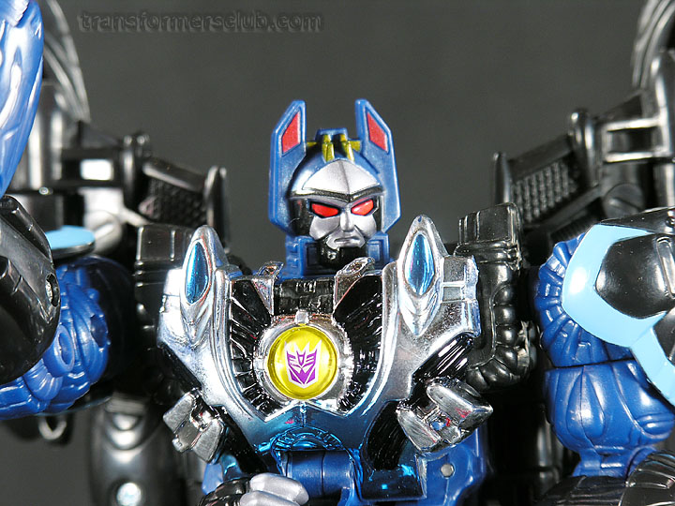
"My power will rain down destruction upon the weak"
Affiliation: Unicronian
Job/Rank: Military Operations Commander
Player: Supercyclonus
Note: Powerful, Arrogant and utterly ruthless, he is a tactical battlefield commander who leads by brutal example. Marauder is powered by a micro-singularity giving him virtually unlimited power and strength. This power can be directed into his weapon-arrays for a variety of effects.
Beast/Vehicle Modes:
(1) Star-Fighter
(2) Ground-Assault Vehicle
(3) Hydro-Foil
(4) 2-Headed Dragon
(5) 1-Headed Dragon
(6) Griffin
(7) Bat
(8) Hand
(9) Elephant
Skills:
- Charisma
- Battle-Tactics
- History
- Sharp shooting
- Communications/Intelligence Gathering
- Interrogation
- Hunting/Tracking
Weapons:
- Laser cannon
- Energy Blades
- Charged Missiles/Rockets
- Multi-ordinance Missiles
- Stunning beams
- Anti-matter cannons
- Plasma Bolts
- Corruscating Flares/Blasters
- Zero Kelvin Dragon Breath
- Sonic Attacks
- Micro serrated Claws/Teeth

Brief History
(Much of this information is OOC knowledge, as it has not been officially revealed yet)
Marauder is constructed from G3 research done by Vorpal on the remains of Azure-blade, as well as alien technology found on an asteroid that had crash landed on the moon several months ago. His personality is remodulated from a cloned version of the Megatron/Galvatron fusion stolen from Hydras and overlaid on the spark ripped from Myrmidon. He has also been infused with the remains of the corrupted Matrix that once resided in Cyclonus and Rodimus. While he has displayed some knowledge stemming from the Decepticon reawakening in the 1980's, whether he has the complete memories of the Megatron and Galvatron remains to be seen.
He was constructed by Vorpal to take over the planet Earth, but the influence of the corrupted Matrix from Cyclonus has thrown unknown variables into his personality and goals. So far his current aims have not yet been fully revealed.

